Here is your task

It’s omnipresent: telecom marketing. Better price here. Better service there. Best for small businesses here. Best for young urbanites there. But what do customers really want? Our client, a big telecom company needs to know. This email just arrived for you:

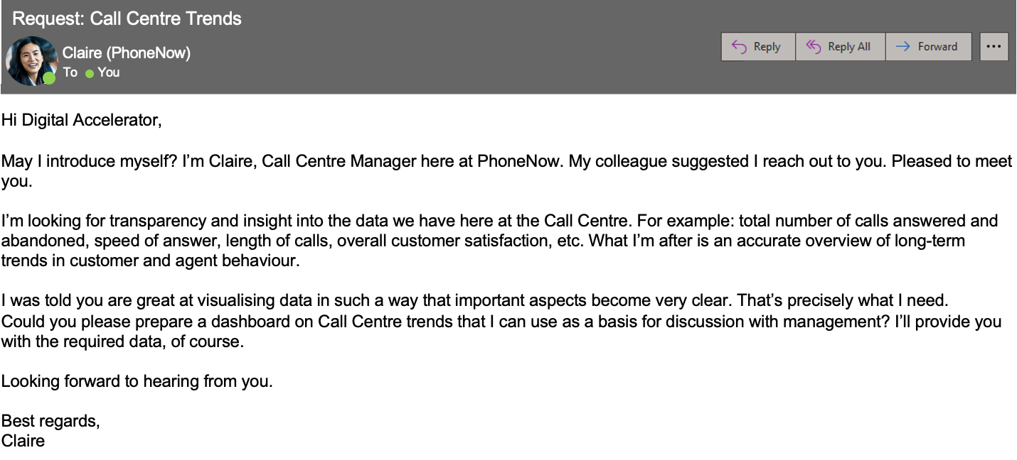

Create a dashboard in Power BI for Claire that reflects all relevant Key Performance Indicators (KPIs) and metrics in the dataset. Get creative!

**Possible KPIs include (to get you started, but not limited to):**

* Overall customer satisfaction
* Overall calls answered/abandoned
* Calls by time
* Average speed of answer
* Agent’s performance quadrant -> average handle time (talk duration) vs calls answered

Here are some resources to help you

Use the linked resources for helpful guidance on completing your task.

Here is a hint: Calculating the following measures could help to define proper KPIs:

# of men

# of women

# of leavers

% employees promoted (FY21)

% of women promoted

% of hires men

% of hires women

% turnover

Average performance rating: men

Average Performance rating: women

Your task is to do the following:

Define relevant KPIs in hiring, promotion, performance and turnover, and create a visualisation

Write what you think some root causes of their slow progress might be

**Be aware, that you need a Windows Software to download Power BI Desktop.**

[[](https://powerbi.microsoft.com/en-us/desktop/)](https://powerbi.microsoft.com/en-us/desktop/" \t "_blank)

**[PowerBI Desktop Download Link](https://powerbi.microsoft.com/en-us/desktop/" \t "_blank)**

[Here's a link to download PowerBI to your desktop for free!](https://powerbi.microsoft.com/en-us/desktop/" \t "_blank)

**[Click to download Power BI →](https://powerbi.microsoft.com/en-us/desktop/" \t "_blank)**

[[](https://cdn.theforage.com/vinternships/companyassets/4sLyCPgmsy8DA6Dh3/01%20Call-Center-Dataset.xlsx)](https://cdn.theforage.com/vinternships/companyassets/4sLyCPgmsy8DA6Dh3/01%20Call-Center-Dataset.xlsx" \t "_blank)

**[Call Centre Dataset](https://cdn.theforage.com/vinternships/companyassets/4sLyCPgmsy8DA6Dh3/01%20Call-Center-Dataset.xlsx" \t "_blank)**

**[Click to download file →](https://cdn.theforage.com/vinternships/companyassets/4sLyCPgmsy8DA6Dh3/01%20Call-Center-Dataset.xlsx" \t "_blank)**

[[](https://www.youtube.com/watch?v=yKTSLffVGbk)](https://www.youtube.com/watch?v=yKTSLffVGbk" \t "_blank)

**[Introduction to Power BI](https://www.youtube.com/watch?v=yKTSLffVGbk" \t "_blank)**

**[Click to watch introduction →](https://www.youtube.com/watch?v=yKTSLffVGbk" \t "_blank)**

Do you want to learn more? Level up by listening to a portion (or all!) of our podcasts linked below and read our articles.

**Podcasts**

* [PwC's Tech While You Trek: Data Visualization](https://pwctechwhileyoutrek.buzzsprout.com/1150349/4885124-pwc-s-tech-while-you-trek-data-visualization)
* PwC's [Tech While You Trek: PwC's Digital Upskilling Journey](https://pwctechwhileyoutrek.buzzsprout.com/1150349/5001527-pwc-s-tech-while-you-trek-pwc-s-digital-upskilling-journey)

**Further information**

* [Transforming your workforce through upskilling](https://www.pwc.com/us/en/tech-effect/automation/workforce-upskilling-strategy.html)
* [Workforce of the Future](https://www.pwc.com/us/en/services/consulting/workforce-of-the-future/workforce-inside-podcasts/workforce-inside-upskilling.html)
* [Upskilling: Creating a secure future through digital skills](https://www.pwc.ch/en/insights/upskilling-creating-a-secure-future-through-digital-skills.html)
* [How we teach digital skills at PwC](https://hbr.org/2018/10/how-we-teach-digital-skills-at-pwc)

Upload your Dashboard

**Select a File**or drag it here.